TWISTED PAIR TRANSMISSION SYSTEM – Passive Series
ITEM NO.: TTP111HD HD Video Transceiver (BALUN)
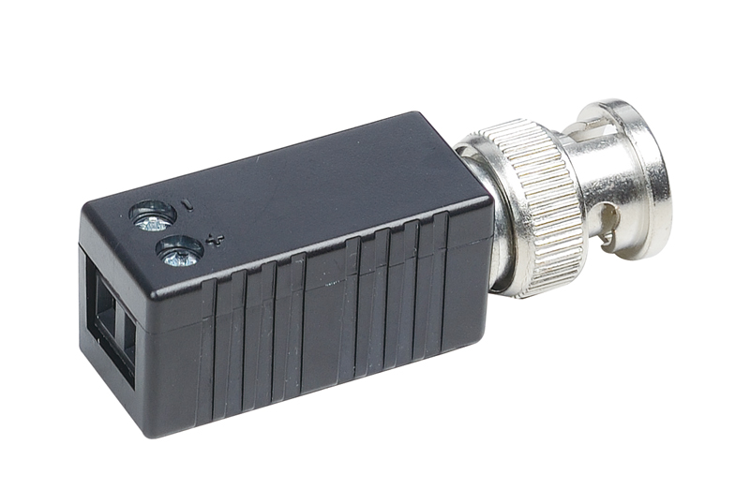
Features:

● To send HD-CVI, HD-TVI, AHD signal 720p at 300 meters, 1080p at 200M .over UTP cable.
- BNC male to screw terminal for easy connection.
● Compact and mini size, could mount multiple units behind multiplexer, Quad, DVR..etc
● Passive, No power required.
● Eliminate Coaxial Cable.
● To work with Active transmitter TTA111HDT, Active receiver TTA111HDR for extra long distance transmission.

Panel View:



Installation View
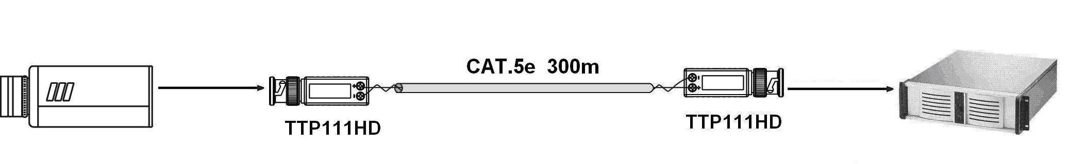

Specification:
ITEM NO. | TTP111HD
Video Input (BNC Connector) | 1
Video Input | 1V p-p, 75 Ohms
CABLE | Twisted Pair CAT 5
Bandwidth | 50Hz ~ 47MHz ( -3dB )
Transmission Distance | Color: 300 meters
RJ-45 Output | Terminal
Power | X
Temperature | Operation: 0 to 55℃, Storage: -20 TO 85℃, Humidity: up to 95%
DIMENSIONS W x H x D mm | 14.5 × 49.5 × 15.5
Weight g | 18

